**Ideation Phase**

**Define the Problem Statements**

|  |  |
| --- | --- |
| Date | 19 September 2022 |
| Team ID | PNT2022TMID52685 |
| Project Name | Project - Developing a Flight Delay Prediction Model using Machine Learning |
| Maximum Marks | 2 Marks |

**Problem Statement :**

Over the last twenty years, air travel has been increasingly preferred among travellers, mainly because of its speed and in some cases comfort. This has led to phenomenal growth in air traffic and on the ground. An increase in air traffic growth has also resulted in massive levels of aircraft delays on the ground and in the air. These delays are responsible for large economic and environmental losses. According to the Bureau of Statistics HOS), hoor 20% of all flights are delayed by 15 minutes or more. Flight delays causes a negative impact, mainly economical for airport arities, commuters and airline industries as well. Therefore, this study develops a novel spatial analysis approach to explore the delay and canal factors which is able to take dependence and the possible problem involved including error correlation and variable lag effect of canal factors on delay into account. The main objective of the model is to predict flight delays accurately in order to optimize flight operations and minimize delays.

Using a machine learning model, we can predict flight arrival delays. The input to our algorithm is rows of feature vector like departure date, departure delay, distance between the two airports, scheduled arrival time etc. We then use decision tree classifier to predict if the flight arrival will be delayed or not. A flight is considered to be delayed when difference between scheduled and actual arrival times is greater than 15 minutes. Furthermore, we compare decision tree classifier with logistic regression and a simple neural network for various figures of merit.

**Example:**

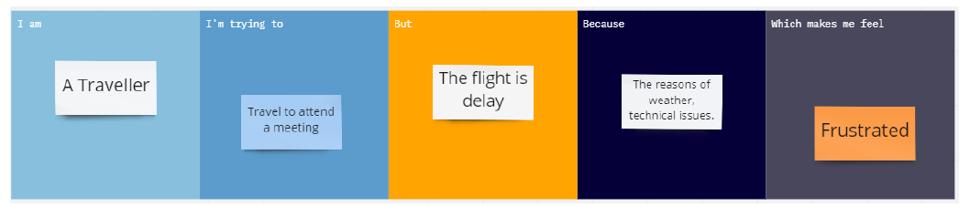

|  |  |  |  |  |  |
| --- | --- | --- | --- | --- | --- |
| **Problem Statement (PS)** | **I am (Customer)** | **I’m trying to** | **But** | **Because** | **Which makes me feel** |
| PS-1 | A Traveller | Travel to Attend a meeting | The flight is delay | The reasons of weather,Technical issues etc.. | Frustrated |